

**LOVELY**

**PROFESSIONAL**

**UNIVERSITY**

**Cse326 project REPORT**

**TOPIC: - car rental system**

**SHIBANSU MANDAL (12208432)**

**RAM SWARUP SURIN (12208434)**

**NAVANEETH ASHOK (12208944)**

**ACKNOWLEDGEMENT**

I would like to express my sincere thanks of gratitude to my teacher **Dr. Mohammad Faiz**, for his valuable guidance and support in completing my project.

I would also like to express my gratitude towards our Chancellor and Vice-chancellor, for providing me with all the facility that was required and I am also thankful to my classmates who helped a lot in completing my project.

**INTRODUCTION**

We developed this project to book a car on rent at the fare charges. In the present system, all booking work is done manually and it takes very hard work to maintain the information about booking and cars. If you want to find which vehicle is available for booking then it takes a lot of time. It only makes the process more difficult. The project aims to automate the work performed in the car rental management system like generating daily bookings, records of cars or cabs available for booking, records of routes available, rental charges for cars for every route, and storing records of the customer.

A car rental management system is a car booking software that provides a complete solution to all your day-to-day car booking office running needs. The cab rental management system is a unique and innovative product.

This system gives the following features to the customers:-

**Registration:** In this system, users have to become registered users to rent a car. Users have to fill in their contact information like their name, address, and mobile number in the registration form. After submitting the form he gets a username and password to log in to the system.

**Date Scheduling:** The user can select the date of car booking. To book a car on the selected date he has to give pick-up place information and drop-off place information.

**ABSTRACT**

In the present world, people always try to reduce their workload by using technology. Traveling is one of the activities done by people to reduce their stress. In our project, we reduced the task of renting cars by taking the advantage of the present technology. Conventionally if someone has to rent a car, they must go to the renting company and select the vehicle and do the paper works for complete the procedure. Doing the conventional procedure is a tedious task, to avoid this we have simplified the task and made it online. With the online method people can select the vehicle online and by giving fewer details they can perform the booking. The user must create an account on the website by giving his details and then he will directly get the details of the vehicles available and they can book the vehicle according to their timing. By having an online method, the workload will be reduced to a greater percentage, by Compared with conventional manner the online method is much easier.

**HARDWARE REQUIREMENTS**

|  |  |
| --- | --- |
| **Processor** | Core i3 or Higher/AMD Processors. |
| **Hard Disk** | 50GB or Higher (Recommended). |
| **RAM** | 4GB or Higher (Recommended) |
| **OS** | Windows 7 or Higher (Recommended). |

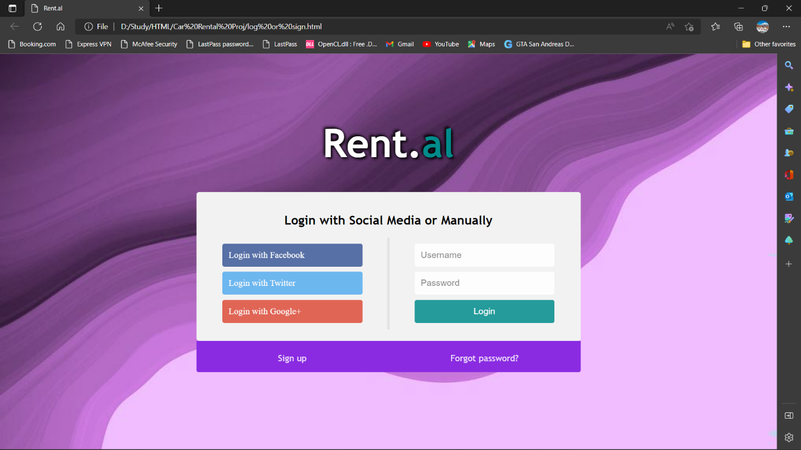

**HOME PAGE:-**

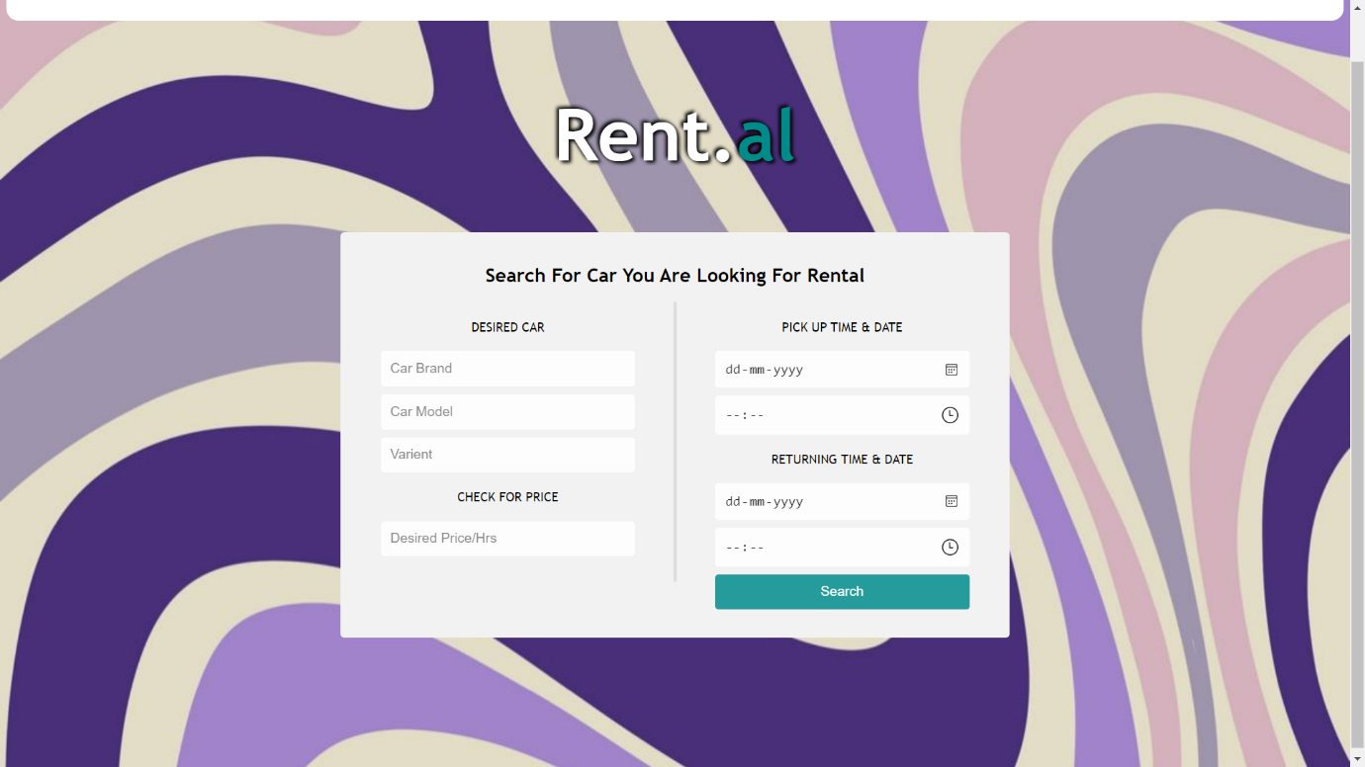

**SERVICE PAGE:-**

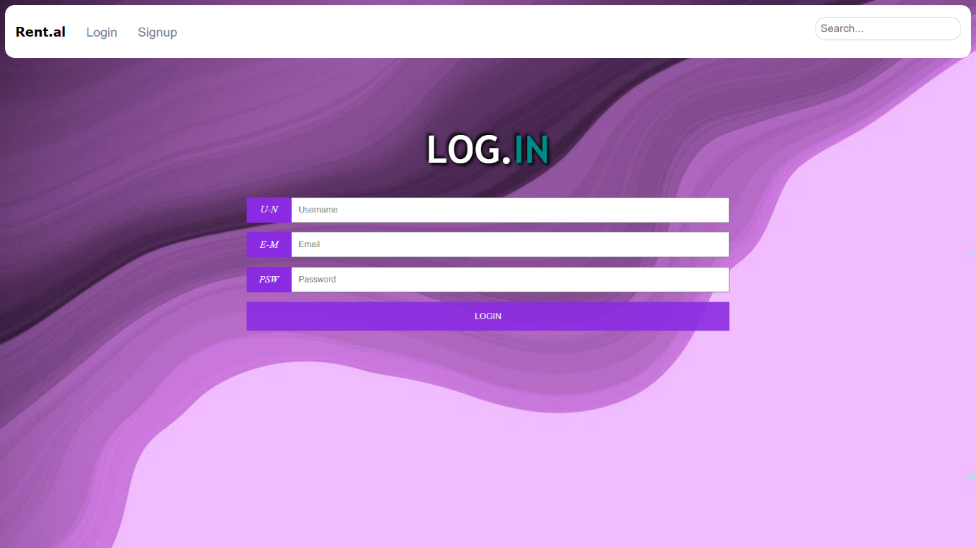

**LOGIN PAGE:-**

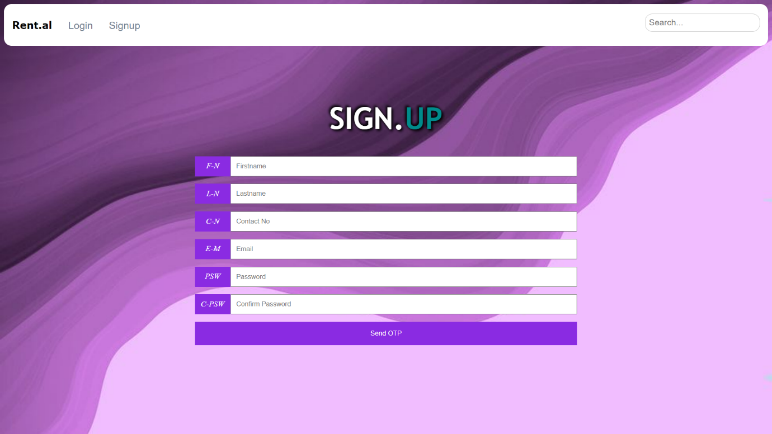

**SIGNUP PAGE:-**

**CONCLUSION**

Car rental business has emerged with a new goodies compared to the past experience where every activity concerning car rental business is limited to a physical location only. Even though the physical location has not been totally eradicated; the nature of functions and how these functions are achieved has been reshaped by the power of internet. Nowadays, customers can reserve cars online, rent car online, and have the car brought to their door step once the customer is a registered member or go to the office to pick the car. The web based car rental system has offered an advantage to both customers as well as Car Rental Company to efficiently and effectively manage the business and satisfies customer's need at the click of a button.